UPS

300VA～1000VA

USER`S GUIDE
INTRODUCTION……………………….…………………………………….1
FEATURES…………………………….…………………………….………..1
SAFETY INSTRUCTIONS……………………………………….…..………2
GETTING STARTED………………………………………….……………...3
THE DISPLAY PANEL…………………………………………………….…3
SPECIFICATIONS……………………………………………………………4
SOFTWARE INSTALLATION………………………………………….……5
UPS TROUBLESHOOTING………………………………………………... 5

1
INTRODUCTION

- Thanks for buying one of these UPS Series. This Guide can use on:
- 300VA ~ 1000VA
  - Reading this USER`S GUIDE first before you start.
  - Attached Warranty Card that service person can keep record of the UPS`s status.

UPS (Uninterruptible Power Supply) Series Introduction
All UPS insist the quality on all of products, which is designed for PC and other peripherals only. Our UPS`S have various kinds of capacity for each equipment. These Series are compact, low noise and easy-to-use UPS which can solve different power problems. They provide stable, clean power, and prevent data loss caused by outages and brownouts.
FEATURES

- SELF TEST:
Self test each time switched on.
When UPS is turned on, it makes self-test to provide a reliable operation and prevent any damage caused.
- BATTERY PROTECTION:
Auto self-test and discharge protection.
- DC START CAPABILITY:
The UPS can be activated without utility power.
- UPS POWER SUPPLIED OUTLETS:
Line-Interactive UPS+AVR
Allows 75% to 125% input voltage range-best protection for computer equipment.
With AVR function (boost & buck), UPS provides a stable power to the loads as the input voltage fluctuates.
- ELECTRICAL PROTECTION:
Automatic cut off on short circuit or Input Circuit Breaker. If UPS is overload, this circuit breaker will trip to disconnect the unit from utility power. Then the black button will pop up, and none of the surge protection outlets will provide power. Unplug at least one piece of equipment, and reset the Circuit breaker by pressing the button back into place.
- MODEM/NETWORK PROTECTION:
RJ45 JACK(option) : Simultaneous protection for network, telephone, fax & modem.
- AUDIBLE ALARM:
Battery Back-up: slow beeping (10 seconds) Battery Low and Overload or AC Overload: Rapid beeping (1 Second)
- INTERFACE AND SOFTWARE:
USB Interface: Software for MS-Win98/ME/2000.
RS-232 Interface: Software for MS-Win98/ME/2000,Novell, and Linux
- CPU MICRO PROCESS CONTROL, USE WITH STABILITY.
2

- GREEN FUNCTION:
If the battery is discharging under no load, will shut down automatically to keep the span life of battery
- FULL-TIME SURGE PROTECTION:
The power coming from the wall outlet may damage your equipment by the bad quality power, but full-time Surge protection intercepts deadly electrical spike and prevents hardware damage.
- EMI/RFI FILTERING:
The power coming from the wall outlet may damage your equipment by electromagnetic or radio frequency interference. UPS intercepts the interference by inductor and capacitor and provides clean power.
- Full time surge protection outlets: It puts an end to concerns about surges, spikes, sags, brownouts, and even lightning strides. Plug equipment that does not require power during a utility power failure into these outlets. There could include a printer, fax scanner, etc. (option)
- INDICATOR
POWER & CHARGE | GREEN LIGHT ON
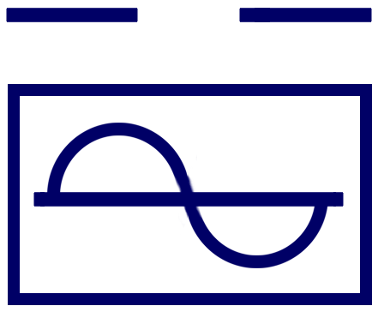BACK UP | GREEN LIGHT FLASHING
OVER LOAD | RED LIGHT ON & AUDIBLE ALARM, DISPLAY BEFORE UPS SHUTDOWN AUTOMATICALLY
CHECK BATT | RED LIGHT ON WHEN BATT FAULT
SAFETY INSTRUCTIONS

CAUTIONS
- UPS is built in potential high voltage. Do not remove the case by yourself to get hurt. Contact us or reseller if you have any question.
- Do not pill any liquid on the Unit or inside the Unit.
- Avoid putting the UPS near high humidity environment or near liquid, such as water, chemical solution…
- Avoid putting the UPS where it will be exposed to direct sunlight or any heat surroundings
- Keeping the hot holes smoothly to release the heart in UPS.
- Using grounding input power cable to connect UPS.
- Do not use UPS on laser Printer because of the high start-up current.
- Do not use the UPS outlets on house electric equipment, such as hair dryer,air conditioner, and refrigerator…

REPLACEMENT AND MAINTENANCE OF THE BATTERY
- Checking the quantity and the model number before replacing the battery.
- Do not replace the battery by yourself, please call the professional people to do it.
- While you are processing the battery, keep away fire to avoid explosion.
- Do not open or damage the case of the battery, because it contains toxic electrolyte that could be harmful your skin or eyes.
- There are high voltage and current with in the battery. Please place it out of children reach.
3
6. Maintaining the Battery --- If you do not use the UPS for long period of time, please recharge the battery over 12 hours every 3 months.
GETTING STARTED

Unpacking Your UPS
Unpacking the UPS to check if the product is damaged, if you find any damage, call the vendor.

Installing UPS
- Make sure the AC power voltage is identical with the voltage in the rear panel of the UPS
- Press ON/TEST switch, the Green light “ON”, that means AC power goes into the UPS.
- Connect the power strip on the computer or other peripherals to the outlets on the UPS. Then turn on the computer, and then unplug the I/P power cord on the UPS to test the operation of the UPS.
- Turning on the UPS to recharge for 8 hours before using it. That can recharge the battery. You can also use it before you recharge completely, but the back up time will be shorter than the full battery capacity.
- To turn off the UPS, please press ON/TEST switch until the LED light is “OFF”.
- Do not use UPS on Laser because of the high start-up current.

THE DISPLAY PANEL
The Top Panel:
1. 500VA～1000VA
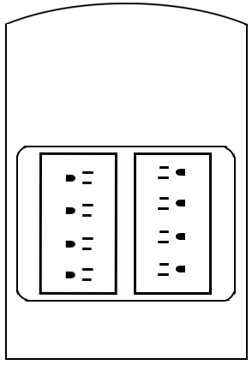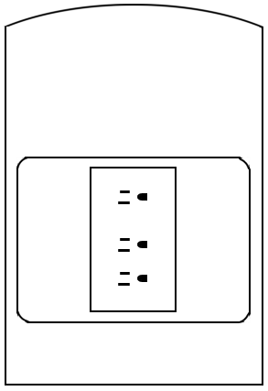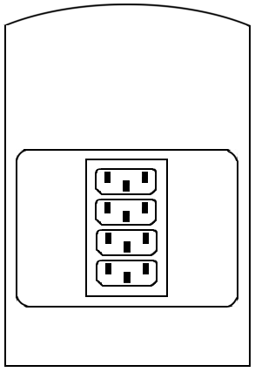
(A) (B) (C)

2. 300VA～650VA
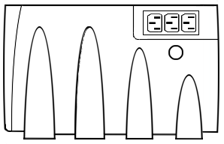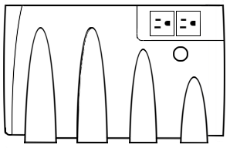
(A) (B)

Surge
UPS
For Large
A/C adapter
Surge
UPS
UPS
Circuit
Breaker
Surge
UPS
Circuit
Breaker
4

The Rear Panel:

1. 500VA～1000VA 2. 300VA～650VA
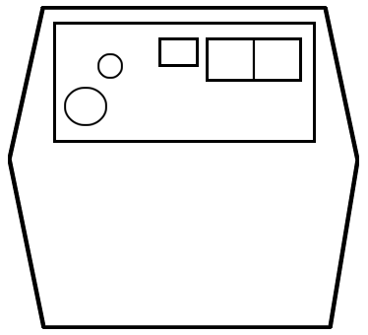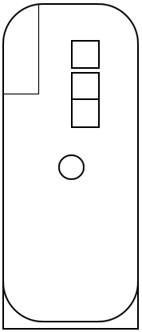
SPECIFICATIONS
Model | 300VA ~ 650VA | 500VA ~ 1000VA
Input Volts Range (on line) | 110V(80V~140V) / 220V(160V~280V)
Input Frequency | 50 OR 60 ± 3HZ
(AVR) Output Volts Range | 110V OUT: 110V±10% / 220V OUT: 220V±10%
Output Volts On Battery | 110VAC±5% / 220VAC±5%
Output Frequency On Battery | 50 OR 60 ± 1HZ
Battery Run Time | 10~30 MIN
Typical Battery Charge | Rated 4hrs to 90% of full capacity
Battery Protection | Auto self-test and Discharge protection
Self Test | Self test each time switched on
Transfer Time | 2~4ms
Outlets | USA or IEC
Audible Alarm | Battery back-up: Slow beeping (10 Seconds), Battery Low or Overload: Rapid beeping (1second)
Indicators | Green LED On-Line, Back up slash, Red LED Overload: Battery Fault
Interface | USB or RS-232
Environment | Ambient Operating: 0-40℃, 0-95% Humidity, Non-condensing Storage: 15℃~45℃
Audible Noise | <40DBA (1-Meter from surface)
Mute | After 1 min in back up mode
Surge Energy Rating | 240 Joules
Overload | Back-up mode 100% shut down, In AC mode 110% alarms (No shut down)
Electrical Protection | Automatic cut off on short circuit and input circuit breaker
Modem/Network Protection | Rj45(8Wire)One in , One out option for modem or network
Conformance | Applicable
Software (Support) | Option
Dimensions (mm) L x W x H | 275 x 60 x 190 | 270 x 100 x 190

Tel/Modem/Network Protection
Remote Port
Circuit
Breaker
AC Input
Remote
Port
- Note:
There are different types of UPS, please use different types of cable.
1.For USB Communication
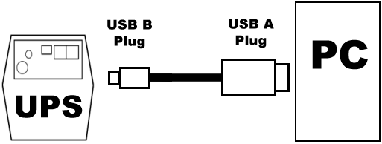
2.For RS-232 Communication
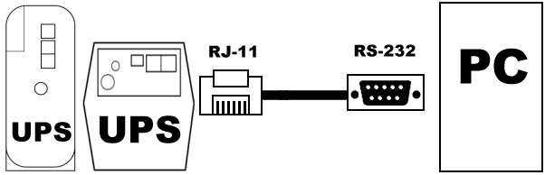

5
SOFTWAVE INSTALLATION

- Introduction
E-Eyes is a unique uninterruptible power supply (UPS) software that offers you unprecedented convenience for the control of any UPS.
Benefits
Early Warning System.
E-Eyes can send warning messages via e-mail or over the LAN. Thus providing an early warning system for power failures, system shutdown and a variety of other scenarios. It guarantees a faster response time, even when you are not in the office.
Saves files before shutdown occurs.
No more lost work due to unexpected system shutdown. When power failure occurs, E-Eyes saves all open files before gracefully shutting down the system.
Cost Savings.
E-Eyes' shutdown and startup scheduling function reduces the amount of power wasted, and therefore results in savings on electricity bills. In addition, E-Eyes also allows for remote control over a TCP/IP network without the need for an expensive SNMP card.
Easy System Monitoring and Tracking.
Users are able to customize various E-Eyes controls such as warning method and alarm messages.

- Features
- UPS monitoring utility
- Scheduled system shutdown
- Graphic display of UPS status
- Warning notification via e-mail
and pager
- Customized controls
- User-definable warnings
- Multi-language versions
- Easy-to-use user interface

UPS TROUBLESHOOTING

Please check the following solutions, if you have any problem on the UPS.
- Make sure the UPS plug is plugged in the outlet correctly.
- Make sure the AC power is in the range of the rated.
- Check the fuse in the rear panel is molten down.
- Make sure the load capacity is within the rated range.
When you call for service, please provide those information’s:
UPS model / Serial number / Breakdown Date / Details about the Status of the UPS.

